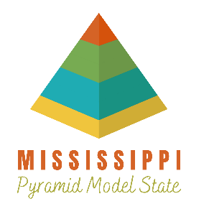
Early Childhood Pyramid Model
Program-wide Readiness Checklist

This checklist will help you reflect as you consider if you would like to join a Program-wide Early Childhood Pyramid Model Cohort.
Name of Program: _________________________________________________________________
Name of Person Completing Checklist: _________________________________________________
Email Address of Person Completing Checklist: __________________________________________

Items to consider | Yes | No | N/A
In your opinion, is there (or will there be) a long term 2-3 year commitment from program leadership?
Does your program currently have policies and/or procedures in place for supporting children with challenging behaviors and children with disabilities?
If you don’t currently have policies and/or procedures in place to support children with challenging behavior or children with disabilities, would you be willing to develop policies and procedures?
*N/A only if question above is Yes
Does your program have the capacity to hold monthly leadership team meetings with representatives from teaching staff, administrative staff, and family members?
Does your program currently promote ongoing professional learning?
Does your program allow observation and feedback from an outside coach/consultant?
Does your program currently have policies and/or procedures in place for staff feedback?
Does your program currently have policies and/or procedures in place for family feedback?
Does your program currently have staff member(s) who would be willing to help with this initiative?
Items to consider | Yes | No | N/A
Has anyone on staff received training on the Pyramid Model Preschool modules?
Has anyone on staff received training on the Pyramid Model Infant/Toddler Modules?
Approximately how many staff members have completed training?  *N/A only if question above is No | # ________
Are your teachers open to having an outside coach/consultant provide feedback based on observations regarding room arrangement, daily schedule, and approach to teaching?
Are the same staff scheduled to work in the same classroom on a daily basis or are you willing to develop consistent scheduling practices?
Have you been working with a coach and/or consultant that has recommended the Early Childhood Pyramid Model?
If yes, please list the coach or consultant’s name:
_______________________________________
Short Answer Questions
What training or coaching that addresses preschool and/or infant toddler social emotional development and/or environment has your staff received? Please specify who provided the training/coaching, how much training/coaching was provided, and what type of training/coaching.

What other initiatives is your program involved in at this time?

How did you hear about the Pyramid Model?

